GRAND TOUR OF POLAND HOSTED BY JOHN GORA
JULY 13 - 27, 2022

Warsaw ▪ Malbork ▪ Gdansk ▪ Torun ▪ Czestochowa ▪ Wadowice ▪ Zakopane ▪ Wieliczka ▪ Krakow

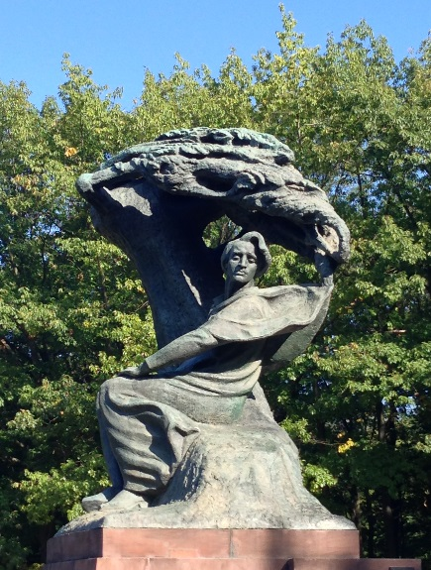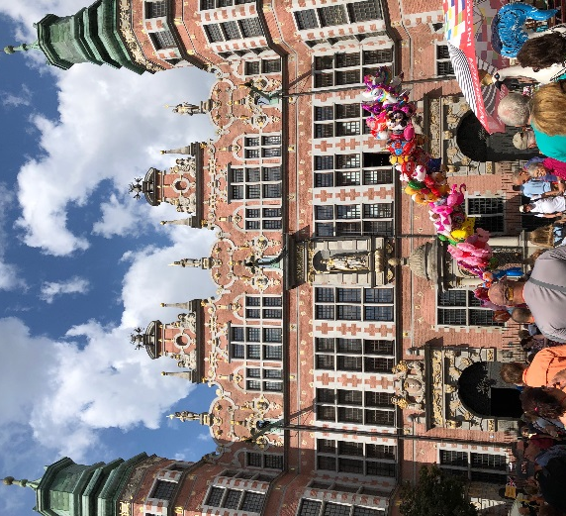

JUL 12 - TUE DEPART CANADA / USA ON TRANSATLANTIC FLIGHT - ASK US ABOUT YOUR FLIGHT OPTIONS.

JUL 13 - WED Arrive Warsaw (Dinner)
Arrive Warsaw and transfer to our hotel. ( Transfer included only if travel on group flight )
Welcome dinner tonight will be at our hotel.
Overnight in Warsaw at the Sofitel Victoria, ul. Krolewska 11, tel: 48 22 657 8011

JUL 14 - THU Warsaw (Breakfast, Lunch)
Our walking tour of the Old Town includes the Tomb of the Unknown Soldier, Castle Square, and Old Town Square.
We then continue by coach for a driving tour that takes us past the Palace of Science and Culture, the former Warsaw Ghetto and National Opera House. Stopping at Lazienki Park we visit the famous Chopin Monument and then stroll through this wonderful green space in the heart of Warsaw to see the Palace on the Water. After lunch, the rest of the day is at your leisure.
Suggestions for your free time: The Chopin Museum, POLIN Museum of Polish Jews, or the 1944 Uprising Museum.
In the evening we invite you to enjoy us for a spectacular sound and light display at the Multimedia Fountain Park.
Overnight in Warsaw at the Sofitel Victoria, ul. Krolewska 11, tel: 48 22 657 8011

JUL 15 - FRI Warsaw (Breakfast, Dinner)
A short drive this morning along the Royal Route leading from the Royal Castle in Warsaw will take us to the wonderful baroque Royal Residence of King John Sobieski III in Wilanow. The Palace boasts an extensive art collection as well as beautifully manicured gardens. After our visit we return to our hotel and the rest of the day is at your leisure.
In the evening we invite you to dinner at one of Warsaw's fine restaurants.
Overnight in Warsaw at the Sofitel Victoria, ul. Krolewska 11, tel: 48 22 657 8011

JUL 16 - SAT Warsaw - Malbork - Gdansk (Breakfast, Lunch)
After breakfast we leave Warsaw and drive to Malbork Castle which was built in 1406 by the Teutonic Knights, a German Roman Catholic religious order of crusaders. Malbork is the largest castle in the world as well as the largest brick building in Europe.
Upon arrival in Malbork we will first have lunch at the “Gothic” Restaurant right on the castle grounds and then we will tour the castle. Afterwards, we continue north to Gdansk for our overnight. The evening in Gdansk is at your leisure.
Overnight in Gdansk at the Gdansk Hilton, ul. Targ Rybny 1, tel: 48-58-778-7100

JUL 17 - SUN Gdansk (Breakfast, Dinner)
After breakfast we will meet our local guide to explore Gdansk. Our walking tour of Gdansk will highlight the main sights such as the Golden Gate, the Long Market with its grand mansions decorated with late Renaissance and Baroque facades, the Artus Court, St. Mary's Basilica, and Mariacka Street, with its gabled terraced houses and elegant boutiques, a great place for shopping!
We then take a short drive to the Solidarity Monument and the European Solidarity Centre, which is a museum devoted to the history of Solidarity, the Polish trade union and civil resistance movement, and other opposition movements of Communist Eastern Europe. The museum is located next to the entrance to the famous Gdansk shipyard. Lunch and afternoon is on your own. Our dinner tonight will be at a local Kashubian restaurant with folklore.
Overnight in Gdansk at the Gdansk Hilton, ul. Targ Rybny 1, tel: 48-58-778-7100
JUL 18 - MON Gdansk - Sopot - Gdansk (Breakfast, Dinner)
The morning is yours to explore on your own or you can join us to visit the World War II Museum in Gdansk.
In the afternoon we sail * from Gdansk to Sopot where we disembark on the longest & oldest wooden pier in Europe.
* subject to weather and water conditions, if unfavorable we will drive to Sopot. Free time to stroll the pier and explore the fashionable seaside resort. Don’t miss the pedestrian street "Monte Cassino" with its many restaurants and cafes as well as the famous Crooked House. In the evening join us for a casual dinner at “Bulaj” restaurant by the seaside in Sopot.
Overnight in Gdansk at the Gdansk Hilton, ul. Targ Rybny 1, tel: 48-58-778-7100

JUL 19 - TUE Gdansk - Torun - Czestochowa (Breakfast, Dinner)
Morning departure from Gdansk, driving south we will stop in Torun for a walking tour of this medieval town where Nicolaus Copernicus was born. Torun has long been famous as a center of gingerbread and is truly one of the most magnificent historic cities of Poland, its Old Town has been included on the UNESCO list. After our tour you will have free time for lunch and shopping before we continue to Czestochowa. Early evening arrival in Czestochowa for dinner and overnight.
Overnight in Czestochowa at Arche Hotel, ul. Olenki 20, tel: 48-34-347 4074

JUL 20 -WED Czestochowa - Auschwitz - Wadowice - Zakopane (Breakfast, Lunch, Dinner)
In the morning we will visit the Jasna Gora Monastery, Poland's most important shrine with the Black Madonna. Afterwards we drive to Auschwitz to the site of the former Nazi Concentration Camp where millions lost their lives during the Holocaust.
We continue south to Wadowice, the birthplace of St John Paul II. We will visit the church where the young Karol Wojtyla was christened and later served as altar boy. In the early evening we arrive Zakopane for dinner and overnight.
Overnight in Zakopane at Mercure Kasprowy , ul. Szymaszkowa 1, tel: +48 18 202 40 00

JUL 21 - THU Zakopane (Breakfast, Dinner)
After breakfast see the highlights of Zakopane including the wooden chapel at Jaszczurowka, the ski-jump hill, and the Shrine of Our Lady of Fatima. Our tour will end with a cable car (funicular) ride to the top of Gubalowka Mountain for a great view of the Tatra Mountains. After descending from Gubalowka you have free time to shop the colorful open market place where you will find leather goods, sheepskin items, local cheese, and all kinds of wonderful gifts and souvenirs for yourself and for friends at home. The rest of the afternoon is at your leisure. In the evening join us for dinner at a lively local inn.
Overnight in Zakopane at Mercure Kasprowy , ul. Szymaszkowa 1, tel: +48 18 202 40 00

JUL 22 - FRI Zakopane (Breakfast, Lunch)
After breakfast we take a drive outside of Zakopane to enjoy a relaxing and picturesque river rafting experience on the Dunajec River. Winding through the spectacular scenery of the Pieniny National Park we will be zig-zagging back and forth across the Polish and Slovak border. Lunch at a local inn and then we return to Zakopane. The rest of the day is at your leisure.
Overnight in Zakopane at Mercure Kasprowy , ul. Szymaszkowa 1, tel: +48 18 202 40 00

JUL 23 - SAT Zakopane - Krakow (Breakfast, Dinner)
Late morning departure from Zakopane to Krakow. After checking in to our hotel we will meet our local guide for a walking tour of Krakow to get acquainted with this lovely medievel town. We will visit Wawel Hill with the gothic Cathedral where many kings of Poland were buried, Florianska Gate, and the Barbican. This 13th-century merchants' town has Europe's largest Market Square, with the Cloth Hall as its centrepiece as well as St. Mary’s Church. Our tour will end with dinner near the Market Square.
Overnight in Krakow at the Andel’s Hotel, ul. Pawia 3, tel: 48-12-660-0288

JUL 24 - SUN Krakow - Wieliczka Salt Mine - Dwor Sierakow - Krakow (Breakfast, Lunch)
After breakfast we drive to the outskirts of Krakow to visit the Wieliczka Salt Mine. The mine is Poland’s top attraction, with underground chambers, grottoes, and chapels all carved from salt. From Wieliczka we will take a short drive to Dwor Sierakow to enjoy lunch at this beautiful Manor House which dates back to 1847. The Manor has been painstkingly renovated and now houses a small hotel, spa, restaurant and an extensive wine cellar. After a leisurely lunch we will return to Krakow.
Overnight in Krakow at the Andel’s Hotel, ul. Pawia 3, tel: 48-12-660-0288

JUL 25 - MON Krakow (Breakfast, Farewell Dinner)
Today the day is yours to enjoy as you wish. Shop for last minute gifts and souvenirs to take home or explore Krakow on your own - perhaps the Rynek Underground Museum or Schindler's Factory. In the evening we meet for our Farewell Dinner.
Overnight in Krakow at the Andel’s Hotel, ul. Pawia 3, tel: 48-12-660-0288

JUL 26 - TUE Krakow. (Breakfast) End of tour - after breakfast transfer to Krakow airport.

(itinerary is subject to minor changes that may be required due to unforeseen circumstances)

SELECTED HOTELS FOR YOUR STAY IN POLAND

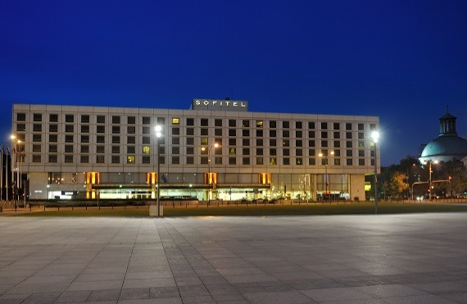 | SOFITEL VICTORIA WARSAW  ul. Krolewska 11  00-065 Warsaw  TEL: 48 22 657 8011
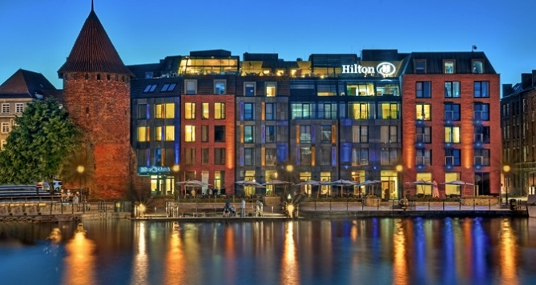 | GDANSK HILTON  Targ Rybny 1  80-838 Gdansk  TEL: 48 58 778 7100
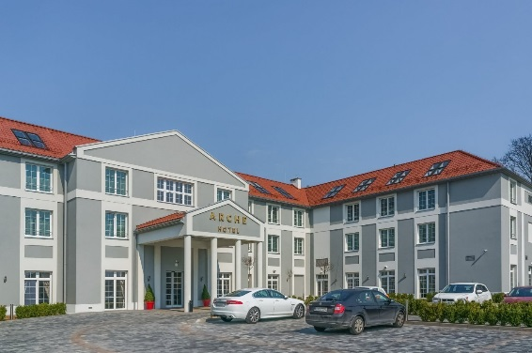 | ARCHE HOTEL  ul. Olenki 20,  42-200 Czestochowa  TEL: 48-34-347 4074
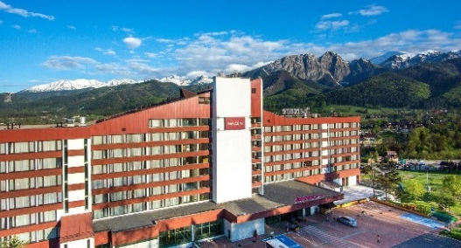 | MERCURE KASPROWY ZAKOPANE  Szymaszkowa,  34-500 Zakopane  TEL: 48 18 202 40 00
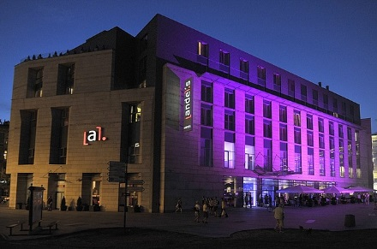 | ANDEL’S HOTEL  ul. Pawia 3  31-154 Krakow  TEL: 48 12 66 00 288

TICO # 4343943
www.chopintours.com

