CENTRAL EUROPEAN TOUR
Hosted by Eddie Biegaj & John Gora
June 29 - July 11, 2021

Prague ▪ Cesky Krumlov ▪ Vienna ▪ Budapest ▪ Zakopane ▪ Krakow
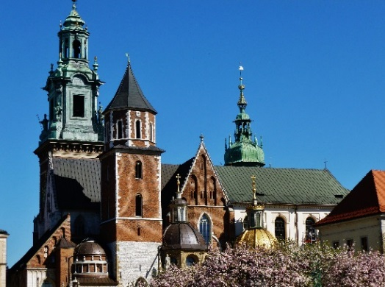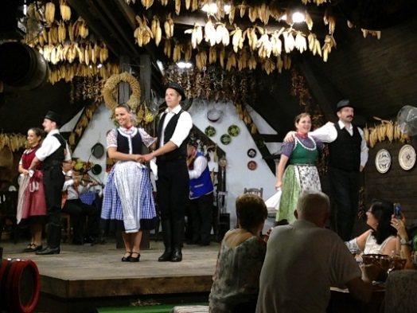

JUN 29 - TUE TRANSATLANTIC OVERNIGHT FLIGHT TO PRAGUE (not included in the land only tour price)

JUN 30 - WED ARRIVE PRAGUE (WELCOME DINNER)
Arrive Prague and transfer to our hotel. ( Transfer included only if arriving on group flight )
Free time until we meet this evening for our Welcome Dinner.
Overnight at the Radisson Blu Hotel in Prague, Zitna 561/8, tel 420 225 999 999 TBA

JUL 01 - THU PRAGUE (B, Dinner with Folklore)
Today we start the tour by bus for a panoramic view of the highlights of Prague such as the Republic Square (Namesti Republiky), Wenceslas Square ( Vaclavske Namesti ), National Theatre, the Prague Castle (UNESCO site) and the Charles Bridge. From here we will walk to the Old Town Square with its famous landmarks such as the Church of Our Lady before Tyn, and the unique Astronomical Clock from the year 1410. We will end our tour at the old town so that you can enjoy the rest of the afternoon at your leisure. Dinner tonight at a local restaurant with traditional folklore.
Overnight at the Radisson Blu Hotel in Prague, Zitna 561/8, tel 420 225 999 999 TBA

JUL 02 - FRI PRAGUE (B) Free day or to be decided .

JUL 03 - SAT PRAGUE - CESKY KRUMLOV - VIENNA (B, L)
After breakfast we drive south to Cesky Krumlov in South Bohemia. Cesky Krumlov is one of the most wonderful medieval cities in Central Europe. This UNESCO heritage site on the Vltava river is perfect for strolling through the maze of cobble-stone streets.
We will have a walking tour of Cesky Krumlov followed by lunch and some free time before we continue to Vienna.
Arrive Vienna in the early evening and the rest of the evening is at your leisure.
Overnight at the Intercontinental Wien, Johannesgasse 28, tel 43 1 71122-196 TBA

JUL 04 - SUN VIENNA (B, Dinner with entertainment)
Today we discover the magical city of Vienna by bus and by foot. Highlights include a tour of the Schönbrunn Palace which was the summer residence of the Habsburg family. Then a drive along the Ringstrasse to see the historical sights such as the State Opera House, the National Museum, the Imperial Palace, the Parliament, the City Hall and finally St. Stephen’s Cathedral where our tour ends. You will have free time to further explore (or shop) along the Kartner Strasse, the famous pedestrian shopping street in center of Vienna, visit one of the many Museums, or relax and enjoy a coffee or lunch at a Viennese Café. In the evening we drive to the wine-growing hills on the outskirts of Vienna for overnight and to enjoy dinner at a typical “heuriger” (local wine tavern).
Overnight at the Intercontinental Wien, Johannesgasse 28, tel +43 1 71122-196 TBA

JUL 05 - MON VIENNA - BUDAPEST (B, Lunch and Hungarian Horse Show)
From Vienna we travel to Budapest stopping on our way to visit the Lazar Equestrian Park for lunch and then a memorable traditional Hungarian Horseman show. After our visit we continue to Budapest for a late afternoon arrival. Check in to our hotel and then the evening is free to enjoy Budapest at your leisure.

* optional late-evening cruise on the Danube - details to be advised - please advise if you might be interested .
Overnight in Budapest at Hotel Zenit Budapest Palace, Apáczai Csere János Utca 7, tel +361 799 8400 TBA

JUL 06 - TUE BUDAPEST (B, Dinner & Folklore)
Today’s tour of Budapest will include: Heroes Square, Millenary Monument, Vajdahunyad Castle, Andrássy Boulevard, Basilica, view from Gellért Hill, Castle district, Matthias Church and Fishermen's Bastion. We will also make a stop at the Great Market Hall of Budapest, named one of the 5 best markets in Europe! The Market was built in the 18th century and after being badly damaged in WWII was extensively restored in the mid 1990’s to become one of Budapest’s greatest attractions. Enjoy strolling through the stalls filled with fresh produce, spices, as well as Hungarian arts and crafts - a great place to pick up souvenirs to take back home! In the evening we drive to the outskirts of Budapest for dinner with a colorful folklore show in a traditional "csárda" atmosphere.
Overnight in Budapest at Hotel Zenit Budapest Palace, Apáczai Csere János Utca 7, tel +361 799 8400 TBA

JUL 07 - WED BUDAPEST - ZAKOPANE (B, D)
Morning departure from Budapest and travel north through Slovakia, stopping at a local inn enroute where you can purchase a light lunch. We continue to Zakopane and arrive at the picturesque resort town, nestled at the base of the Tatra mountains in the late afternoon. Free time to relax and perhaps take a dip in the pool. Dinner tonight will be at our hotel.
Overnight in Zakopane at Mercure Kasprowy , ul. Szymaszkowa 1, tel +48 18 202 40 00 TBA

JUL 08 - THU ZAKOPANE (B, Dinner with folklore)
After breakfast see the highlights of Zakopane including the wooden chapel at Jaszczurowka, the ski-jump hill, and the Shrine of Our Lady of Fatima. Our tour will end with a cable car (funicular) ride to the top of Gubalowka Mountain for a great view of the Tatra Mountains. After descending from Gubalowka you have free time to shop the colorful open market place where you will find leather goods, sheepskin items, local cheese, and all kinds of wonderful gifts and souvenirs for yourself and for friends at home. In the early evening we will take a short drive to the village of Chocholow famous for its unique log-houses. We will stop to visit a local wood-carver and afterwards we enjoy dinner at a nearby highlander inn with lively music and folklore.
Overnight in Zakopane at Mercure Kasprowy , ul. Szymaszkowa 1, tel +48 18 202 40 00 TBA

JUL 09 - FRI ZAKOPANE - DUNAJEC RIVER RAFTING - KRAKOW (B, L)
In the morning we leave Zakopane and take a short drive to enjoy a relaxing and picturesque river rafting experience on the Dunajec River (weather permitting). Winding through the spectacular scenery of the Pieniny National Park we will be zig-zagging back and forth across the Polish and Slovak border. Lunch at a local inn and then we continue our drive to Krakow. After checking in to our hotel enjoy the ambience of Krakow's old town at your leisure - make sure to spend some time in the Market Square this evening.
Overnight at the Andel’s Hotel in Krakow, ul. Pawia 3, tel +48 12 660 0288 TBA

JUL 10 - SAT KRAKOW (D, Farewell Dinner)
We will start our tour this morning by bus to visit the former Jewish district of Kazimierz, which has recently become a very trendy area filled with many charming cafes and restaurants. We then continue to Wawel Hill with the gothic Cathedral where many kings of Poland were buried. We continue by foot to Europe's largest Market Square, with the Cloth Hall as its centrepiece as well as St. Mary’s Church. Our tour will end near the Market Square and then the rest of the afternoon is yours to explore on your own.
In the evening we invite you to our Farewell Dinner at one of Krakow's finest restaurants.
Overnight at the Andel’s Hotel in Krakow, ul. Pawia 3, tel +48 12 660 0288 TBA

JUL 11 - SUN KRAKOW - END OF TOUR (B)
After breakfast end of tour. Transfer back to the airport for your flight home.

(itinerary is subject to minor changes that may be required due to unforeseen circumstances)

Cost of the Land tour is $ TBA per person based on double occupancy
Single room supplement add $ TBA
Land only tour starts in Prague on Jun 30, 2021
Air & Land Package - please ask about airfares from your departure city.

For further information or to book this tour please contact:
Toll-free North America 1-800-533-0369
wanda@chopintours.com

www.chopintours.com

